Universidade do Minho

Sistemas Digitais - Laboratórios

Contadores e Registos de deslocamento

André Machado 66693

   Luís Pedro Araújo 73232

|  |  |  |  |  |  |  |
| --- | --- | --- | --- | --- | --- | --- |
| C | Q0 (2) | Q3 | Q2 | Q1 | Q0 | número |
| 0 | 0 | 0 | 0 | 1 | 1 | 3 |
| 0 | 1 | 0 | 1 | 1 | 0 | 22 |
| 1 | 0 | 0 | 1 | 0 | 1 | 5 |
| 1 | 1 | 0 | 1 | 1 | 0 | 22 |

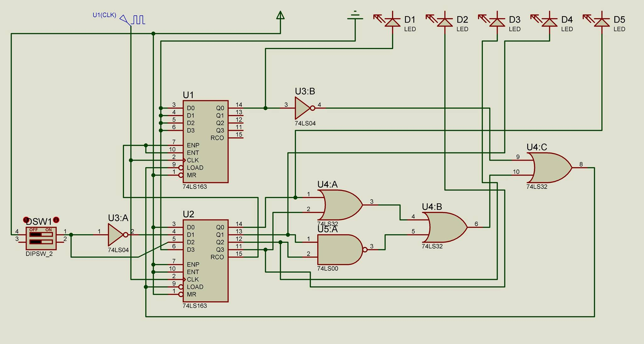

2.

|  |  |  |  |  |  |
| --- | --- | --- | --- | --- | --- |
| Nº | D3 | D2 | D1 | D0 | Xout |
| 3 | 0 | 0 | 1 | 1 | 0 |
| 1 | 0 | 0 | 0 | 1 | 1 |
| 8 | 1 | 0 | 0 | 0 | 0 |
| 4 | 0 | 1 | 0 | 0 | 0 |
| 2 | 0 | 0 | 1 | 0 | 1 |
| 9 | 1 | 0 | 0 | 1 | 1 |
| 12 | 1 | 1 | 0 | 0 | 0 |
| 6 | 0 | 1 | 1 | 0 | 1 |
| 11 | 1 | 0 | 1 | 1 | 0 |
| 5 | 0 | 1 | 0 | 1 | 1 |
| 10 | 1 | 0 | 1 | 0 | 1 |
| 13 | 1 | 1 | 0 | 1 | 1 |
| 14 | 1 | 1 | 1 | 0 | 1 |
| 16 | 1 | 1 | 1 | 1 | 0 |
| 7 | 0 | 1 | 1 | 1 | 0 |

